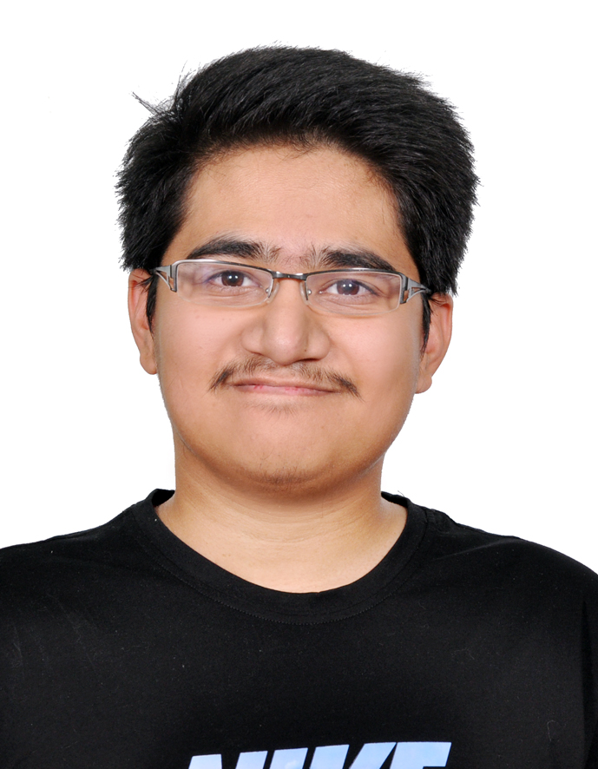
Sayed Jalal Habib Marhamat
Flat 1, Building 435, Road 1513, Block 815
Isa Town, Bahrain
34522784/37115592 – jalalhussainiuuork@gmail.com

Summary
I am a newly graduated university student. In my current role I am a kitchen crew member, but I am always looking for more ways to improve myself

Experience
Position & Company Name | Key responsibilities and achievements | Years
Service Crew  McDonalds Restaurant ,  Exhibition Road | Batch/Grill Operator  Cashier | Nov 2018  -  Present
Associate Accountant  Ashoori Contracting, Salmabad | Manage small business accounts.  Complete tasks/assignments given to me. | June 2018  -  August 2018
Receptionist  Isa Town Public Library, Isa Town | Answer phone calls.  Check out receive books.  Maintain and tidy the bookshelves. | 2014 - 2015

Education
Qualification | Institution | Years
Associate Diploma in Business Administration | University of Bahrain | 2015 - 2018
High School Diploma In Business | Al Naim Secondary Boys School | 2012 - 2015

Skills
Skill | Proficiency level
QuickBooks, Tally and Sage50 Accounting Software. | Expert
MS Office Programs. | Expert
Languages: English & Arabic. | Expert

Hobbies and interests
Video games, Movies, Animals and reading.

References
Available on request.

